Draft Waste and Recycling Strategy (2026)
Contents
Acknowledgement of Country 1
Purpose 2
Background 2
Strategy Objectives 2
Community engagement 4
Data and current performance 5
Implementation, monitoring, evaluation and reporting 7
Service Area 1 – Kerbside collection of waste and recycling 7
Background and current service delivery 7
Challenges and opportunities 8
Actions 10
Service Area 2 – Public realm services 11
Background and current service delivery 11
Challenges and opportunities 12
Actions 13
Service Area 3 – Council operations 14
Background and current operations 14
Challenges and opportunities 15
Actions 16

Acknowledgement of Country
Council acknowledges the Bunurong People of the Kulin Nation as the Traditional Owners of these municipal lands and waterways, and pay our respects to Elders past and present.

Purpose
This Strategy confirms Council’s commitment to improving waste and recycling services to the community and to managing its own waste responsibly.
It supersedes and replaces the old Waste and Litter Strategy 2025.

The Strategy outlines the current waste and recycling services and commits to 30 Actions to improve the service over the next five years.

Background
Waste and recycling is the most significant service provided to the Hobsons Bay community. It impacts all residents and businesses as well as visitors to our municipality and has an annual combined budget that, as of 2026, is approximately $18 million.
A challenging eight years
Over the last eight years, Council has had to manage considerable challenges that have increased costs, increased complexity and reduced community trust in recycling.
The decision by China in 2018 to reject exported contaminated recycling led to stockpiling by recycling companies. This resulted in the ‘Recycling Crisis’ following dangerous fires and the collapse of a major recycling company in 2019.
Community trust in the recycling system reduced and then the COVID-19 pandemic further changed community attitudes. Dumping rubbish in public spaces increased dramatically and some community members became less conscientious about using their kerbside recycling bins.
Innovative service delivery and increased investment
In response to the challenges, Hobsons Bay City Council became the first in Victoria to provide four streams of kerbside collection in 2020. The service was then changed in 2021 in response to community feedback about the frequency of collection of different types of bins.
Council also expanded the types of public litter bins provided and increased spending on cleaning up dumped rubbish.

Strategy Objectives

This Strategy aims to balance four key Objectives to provide the best possible waste and recycling service for our community.

Objective 1 – Meet legislative and regulatory requirements
Council is obliged to deliver waste and recycling services within a regulatory framework including:
Local Government Act 1989 & 2020
Environment Protection Act 2017
Road Management Act 2024
Circular Economy (Waste Reduction and Recycling Act) 2021
Service Standard (in draft since 2024)
Ministerial Good Practice Guidelines 2026 (not compulsory)

Objective 2 – Meet the needs of the community
Within the legislative and regulatory requirements listed above, Council can choose options to best meet the needs of the community. This includes:
  - How frequently bins are collected
  - The size options of kerbside bins
  - Public litter bin types and locations
  - Which contractors can provide the best service
  - What type of service to provide to businesses and community organisations
  - How much education to provide to the community
  - Extent of education and campaigns
  - Whether to offer additional services

This Strategy has taken into account feedback from the community through a range of sources. However, the Hobsons Bay community has a variety of different needs and opinions about waste and recycling so it is challenging to provide a service that suits everyone.

Objective 3 – Improve environmental outcomes
The best environmental outcome is for waste not to be produced at all. As shown in the diagram below, preventing waste and reusing existing items is preferred. However, the reality is that Council and the Hobsons Bay community generates thousands of tonnes each year of waste and recycling that needs to be managed. Disposing of waste to landfill is considered the worst environmental outcome. Using waste to generate energy is better than landfill but not as good as recycling.
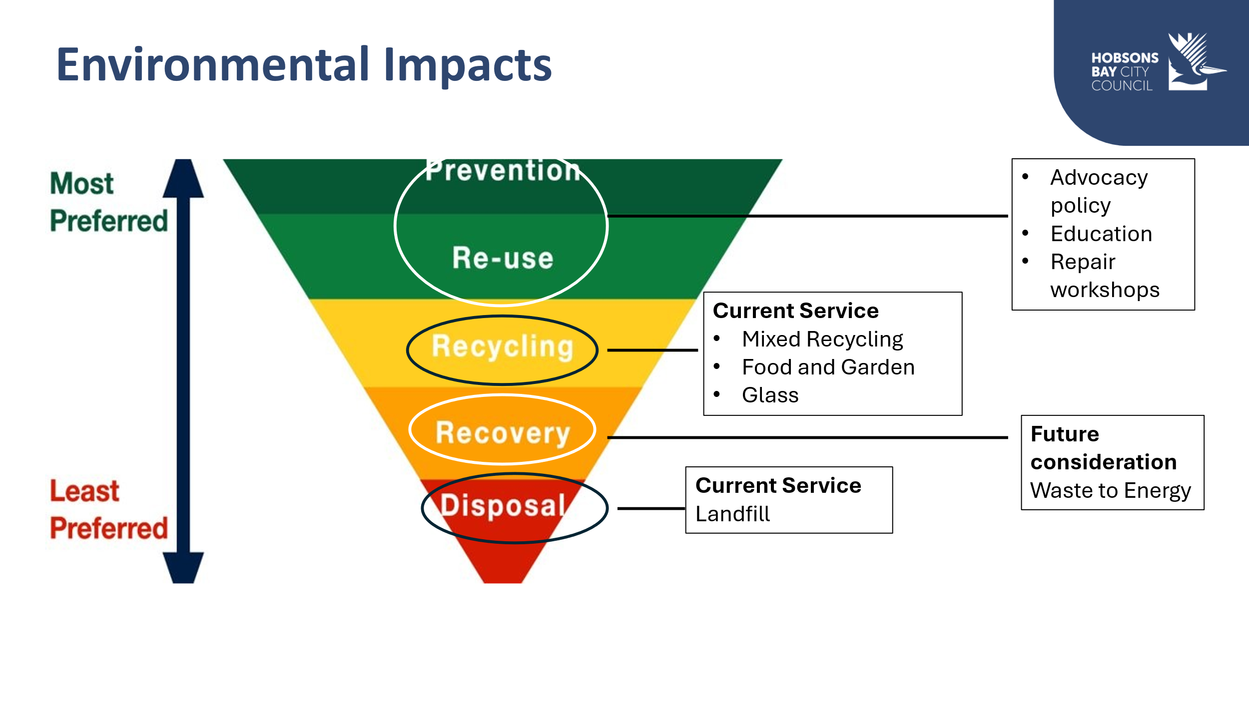

Objective 4 – Deliver a cost effective and efficient service
Waste and recycling services are expensive. Council carefully budgets each year to minimise the cost to the community who are paying for their services through their annual rates and the Waste Service Charge.
Waste and recycling is provided as a ‘universal service’ to increase efficiency. This means that essentially everyone gets the same service. This simplicity helps reduce costs and reduces the risk of mistakes or delays.

Achieving the Objectives is a balancing act
Difficult decisions have had to be made as the Objectives are sometimes in competition with each other. For example, the cheapest or most environmentally friendly options are not always the ones that best meet the needs of the community. Council has used the results of community engagement, research and technical knowledge to help make these difficult decisions.

Community engagement
Council asked the community for feedback about current waste and recycling services including the kerbside collection service, public litter bins and dumped rubbish in August 2025. Over 1,670 community members and organisations participated through online and paper surveys, in-person pop-up events and focus groups. The full report of the engagement is publicly available on Council’s Participate website.
Environmental sustainability emerged as the top priority in this engagement as shown in the graph below.

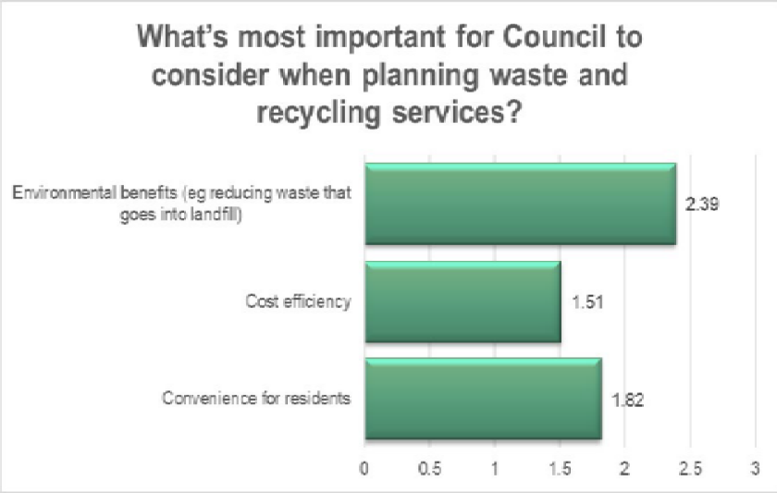

Other insights from the engagement include:
- Strong support for increased education including using bin stickers for residents that are not using their bins correctly
- Strong support for increased ‘drop-off’ locations
- Some confusion about public litter bins and a desire for more bins
- Support for repair/reuse initiatives
- Major concern about littering and dumped rubbish
- Interest in more flexible services for businesses and apartment buildings
- Acceptance that waste to energy needs to be explored as an alternative to landfill but strong concerns about the impacts on communities that live near planned facilities.
Council also undertakes an annual Community Satisfaction survey. Unlike other engagements, participants are chosen at random so aren’t necessarily very interested in waste and recycling. The survey results for kerbside collection over the last few years show a dip in satisfaction when the four-bin system was introduced in 2020. This then improved when the frequency of collection was changed and has continued to improve each year after that.

(Insert graph here)

Data and current performance

Council monitors kerbside collection data closely and provides regular updates on its website.
As shown in the graph below, in 2024-25 the Hobsons Bay community put 49% of their waste into the red-lidded bin which goes to landfill. When additional rubbish is removed from the other bins, this totals 51% to landfill.
In 2020-21 Council had the lowest rate of landfill in Victoria with 35% in the red-lidded bin plus contamination resulting in 40% to landfill.

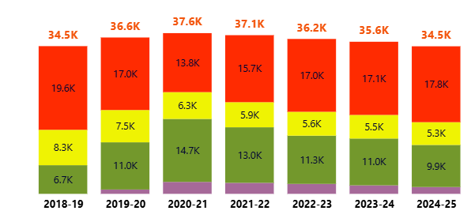

When we look more closely at what is currently going into each bin, we can see how the Hobsons Bay community is using their bins.
- The community is very good at using the purple-lidded glass bin. Only about three percent of the contents are rubbish.
- The yellow-lidded mixed recycling bin still has around 20% rubbish. This is mainly plastic items that can’t be recycled.
- The green-lidded food and garden bin is mostly garden waste. The community as a whole are not putting food in their green-lidded bins.
- The red-lidded rubbish bin has around 30% food waste and 15% recyclables that could be put into other bins and be diverted from landfill.

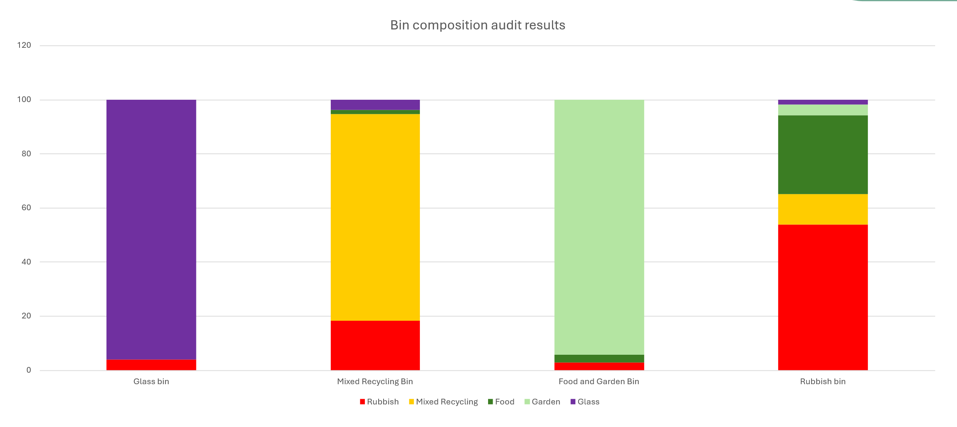

Dumped rubbish is a key concern in the community and this graph shows just how much it has increased since the COVID-19 pandemic. During that time the cost of landfill has also increased dramatically which has motivated some businesses and households to dump their rubbish rather than pay to dispose of it.

Implementation, monitoring, evaluation and reporting
This Strategy will be delivered from 2026-2031 with regular reviews to ensure that Council responds to new opportunities, challenges and technologies over the life of the Strategy.
Council is committed to using evidence and data to measure the success or otherwise of the Strategy Actions and to keeping the community informed. Data will continue to be collected via audits and contractor reporting and will be shared with the community on Council’s website and in the Annual Report.
Over time, it may become clear that some Actions are not delivering the Strategy Objectives or are impacted by external factors such as new regulations, societal changes or waste and recycling industry developments.
Council will adjust its approach as needed and keep the community informed of any changes.

Service Area 1 – Kerbside collection of waste and recycling

“Provide an effective service that reduces waste and increases recycling”

Background and current service delivery
Hobsons Bay City Council was the first council in Victoria to deliver a four-bin kerbside collection service in February 2020. The service was revised in November 2021 following community feedback about how frequently different types of bins are collected.
The service is provided to over 40,000 properties and is delivered via seven large contracts with waste and recycling companies that collect the bins and process the contents.
The service is funded by a Waste Service Charge that is paid by all residential ratepayers that live in stand-alone houses. It is designed to meet the needs of households. However, businesses and apartment buildings can opt-in to pay the Charge if the waste and recycling materials that they generate can be managed by the Service.
The setting and management of the Waste Service Charge is outlined in Council’s Waste Service Charge and Reserve Policy (2022). The Policy is due to be updated in late 2026 so that it can reflect this new Waste and Recycling Strategy. The Victorian Government also provides guidance about calculating the Charge in the Ministerial Guidelines for Best Practice (2026).
The standard service consists of:
- 120L red-lidded rubbish bin collected weekly
- 240L yellow-lidded mixed recycling bin collected fortnightly
- 120L green-lidded food and garden bin collected fortnightly
- 120L purple-lidded glass bin collected monthly
Flexibility is provided for households or businesses that can choose to order extra bins and larger rubbish or mixed recycling bins for an additional cost. Businesses can also choose to reduce their bins if there are issues with storage space.

Challenges and opportunities
Landfill is running out in Victoria and disposal costs are getting more expensive.
- The Victorian Government will not approve any new landfill sites and each year sets a Waste Levy that is paid on every tonne that goes to landfill to encourage everyone to reduce their waste.
- The cost of the Waste Levy has increased dramatically in recent years.
- This has increased the cost of disposing of the rubbish from the red-lidded bins. It has also increased the cost of managing the other bins as many of them have some rubbish in them as well.

New technology to convert waste to energy will be available in Victoria in coming years.
- Extracting energy from waste has a better environmental outcome than landfill but is not as good as recycling or composting.
- There are a handful of waste to energy facilities being planned in Victoria.
- As landfill keeps increasing in price, these facilities could provide options that are also more cost effective.
- There are community concerns about the management of these facilities and the impact they might have on air quality.
- If Council decides to use a waste to energy facility it will require high standards of environmental monitoring in its contractual arrangements.

The Container Deposit Scheme (CDS) has changed the way we manage small drink bottles and cans.
- The amount of material in all bins has reduced as the community are taking their bottles and cans to CDS drop-off points for a 10-cent refund.
- However, reducing bottles and cans in the mixed recycling and glass bins results in a change in contamination reporting. That is, if there are less recyclables in the bins the proportion of rubbish is actually larger.
- Some people are rummaging through bins that have been put out on the nature strip for collection which can cause a nuisance.

Electronic waste and gas cannisters including appliances, batteries, vapes and nitrous-oxide cannisters are becoming more common in kerbside bins.
- It is illegal to send electronic waste items to landfill and expensive to recycle them.
- There is an increased fire risk in bins and trucks which is dangerous for truck drivers, recycling facilities and the general community.
- Vapes are illegal to sell but are still commonly used and are ending up in the kerbside bins.

There are only a few waste and recycling companies in Victoria.
- When Council goes out to the market to tender for waste and recycling contractors, there is limited choice.
- Over time this can mean that prices go up and quality goes down as the existing companies don’t have much competition.
- Hobsons Bay can partner with other councils to try to get better prices and service from the existing contractors through combined, larger contracts.

Community members have different ideas about what kind of service they would like to receive.
- It is challenging to provide a service that suits everyone.
- There has been disagreement in the Hobsons Bay community about how frequently bins should be collected.

There are limits to how much Council can achieve with education programs.
- Education has been effective in helping the Hobsons Bay community understand their four different bins but challenges remain.
- The community has told us that it is important to deliver education programs including bin inspections and stickers.
- There are varied reasons why people put the wrong thing in their bins. Some people need more information and support but others don’t trust the recycling system or don’t believe in the benefits of recycling.

The demographics of Hobsons Bay is changing with an increase in apartment buildings and townhouse developments.
- Many apartment buildings aren’t able to use Council’s waste and recycling service because they don’t always have enough space to store four bins or space to put the bins out on collection day. These buildings use services provided by private companies that can collect larger skip bins and provide more frequent collections.
- New developments sometimes have narrow streets with parked cars which make it difficult for the collection trucks to navigate safely.
- The apartment buildings that do use Council’s waste and recycling service tend to have more rubbish in their recycling bins than stand-alone houses.

The Victorian Government’s Service Standard has been in draft for two years which makes it difficult to plan for changes to the kerbside collection service.
- The Service Standard will confirm a list of what should go in each bin so that there is consistency across Victoria.
- Council can’t deliver new initiatives such as compostable bags for food waste until the Service Standard is confirmed.
- The draft Service Standard doesn’t clearly confirm the minimum service requirements for apartment buildings.

Council can make decisions and deliver programs that help the community to manage their waste and recycling but has very limited influence on the top of the waste hierarchy (see diagram on page 3).
- The best option is to avoid waste and to reuse items rather than put them into a kerbside bin.
- The products that we buy have more packaging and wear out more quickly than in the past.
- Community lifestyles have changed and we order more take away and delivered items that come in containers that can only be used once.

Council doesn’t operate a landfill or transfer station
- We rely on private companies and our neighbouring councils to provide these services to our community.
- Council provides options for “drop -off” days for bulky items or hard-to-recycle items that are then transported to other locations.
- Council also provides a bookable hard waste collection service.

Actions

Council will deliver the following Actions to improve the existing kerbside collection service.
- Provide options for larger bins at an additional cost for apartment buildings and businesses that need more capacity to manage their volumes of waste and recycling.
- Provide accessible waste and recycling services, including smaller bin size options, to support residents with additional needs.
- Support apartment buildings, townhouse developments and non-residential properties with tailored waste and recycling advice and additional bin size options to help them manage space constraints and waste and recycling volumes.
- Expand waste and recycling education programs to include targeted bin inspections and tailored activities for different groups and neighbourhoods in the community.
- Explore cost effective and environmentally responsible options for managing rubbish from the red-lidded bin, including waste to energy, ensuring that community wellbeing is protected.
- Trial public communal drop-off bins for glass and food and garden waste in selected locations for residents that can’t easily access the kerbside collection service.
- Collaborate with other councils through shared contracts and resources to deliver cost effective and efficient waste and recycling services. This includes considering services for high density housing estates.
- Expand safe and convenient options for the community to dispose of e-waste, chemicals and hard-to-recycle items., including:
- increasing community drop-off days
- increasing permanent drop-off locations such as the “Recycling Made Easy” program
- partnering with large apartment buildings.
- Seek a food and garden processing arrangement that allows for the use of compostable plastic bags in the green-lidded bins. **If the new Victorian Standard allows.
- Partner with credible charities and community initiatives that encourage repair, reuse and donation to reduce waste.
- Advocate to the Victorian and Australian governments for stronger regulation, funding and policy to improve waste and recycling outcomes, including:
- Finalising the Victorian Waste and Recycling Standard
- Requiring minimum standards that reduce packaging
- Expanding Product Stewardship programs (requiring manufacturers and retailers to fund recycling and disposal of their products)
- Funding programs to manage the recycling of problematic and dangerous items such as chemicals and vapes
- Supporting new companies and new technologies for recycling.

Service Area 2 – Public realm services

“Keep public spaces clean and reduce waste to landfill”

Background and current service delivery
Hobsons Bay residents, visitors and businesses expect clean and pleasant public spaces. We are proud of our parks, wetlands and foreshore areas which attract visitors from neighbouring municipalities and beyond.
Council manages a range of public spaces including streets and squares that service residential neighbourhoods, retail activity centres and large industry.
Council directly provides waste and recycling services in these public spaces including:
- more than 1,000 public litter bins across 220 locations
- litter collection at 174 selected locations
- street sweeping and beach cleaning services
- clean up of illegal dumping.
We also work with partners such as the Victorian Government and private industry to support them to manage the cleanliness of properties that are outside of Council’s direct control.
All properties that pay the ‘Waste Service Charge’ are eligible for an annual Hard Waste Collection at no extra cost. This includes all stand-alone houses as well as some apartment buildings and some businesses.

Challenges and opportunities

Disposing of waste into landfill is getting more expensive.
- Some people and businesses dump rubbish including building rubble, tyres and household items in public places rather than using the Council provided services or paying for disposal. This is unpleasant for the community and costly for Council to clean up.
- Disposing of rubbish from public bins, litter and street sweeping is also costing Council more each year.
New technology to convert waste to energy will be available in Victoria in coming years.
- Council can consider whether there are better ways to manage waste that is currently going to landfill.
- Extracting energy from waste has a better environmental outcome than landfill but is not as good as recycling or composting.
- There are a handful of waste to energy facilities being planned in Victoria.
- As landfill keeps increasing in price, these facilities could provide options that are also more cost effective.
- There are community concerns about the management of these facilities and the impact they might have on air quality.
- If Council decides to use a waste to energy facility it will require high standards of environmental monitoring in its contractual arrangements.

The Container Deposit Scheme (CDS) has changed the way we manage small drink bottles and cans.
- The amount of litter has reduced as community members are collecting bottles and cans for the 10-cent payment.
- Some people are rummaging through public bins to look for bottles and cans. This can cause damage and mess.
Electronic waste and gas cannisters including appliances, batteries, vapes and nitrous-oxide cannisters are becoming more common and are difficult to manage as waste in public spaces.
- It is illegal to send electronic waste to landfill and expensive to recycle it.
- There is an increased fire risk in bins and trucks which is dangerous for council workers and the general community.
- Vapes are illegal to sell but are still commonly used. Council programs to encourage people to dispose of them safely are consistently vandalised.
Hobsons Bay attracts visitors from outside the local area which can create waste challenges.
- Significant amounts of waste and recycling are generated in peak times during summer and weekends.
- Not all visitors understand Hobsons Bay’s three waste and recycling categories for public bins.
- Visitors may be less motivated than locals to keep public places clean and pleasant.

Changing community demographics and long-standing resident attitudes are influencing household dumping behaviour.
- It can be difficult for residents to manage large items of rubbish when they live in small homes or renting for a short period.
- Many residents are familiar with the practice of placing large items of furniture on the nature strip and are unaware that it is illegal.
- Council coming to clean up dumped furniture and household items promptly can send a signal that this is a convenient way to dispose of these items.

Managing and enforcing illegal dumping of other waste types such as building rubble and tyres is complicated by Council’s limited powers.
- The Environment Protection Agency (EPA) manages enforcement.
- Council can’t clean up dumping or storing of waste on private property.
- Commercial dumping is motivated by cost savings which are higher than current fine consequences.

Actions
Council will deliver the following actions to improve the management of waste and recycling in public spaces.

- Review the number and location of public litter bins across the municipality.
- Review the design of public litter bins to make them easier to use correctly.
- Provide recycling bin options that meet current community needs including trialling options to support the Container Deposit Scheme (CDS).
- Explore new cost effective and environmentally responsible options for managing litter, seaweed, street sweeping and public litter bin contents that can’t be recycled. This includes new options for composting and waste to energy that ensure that community wellbeing is protected.
- Support community clean up activities that encourage pride in our local public spaces.
- Expand Council’s Hard Waste service so that:
- the existing free service can be accessed by a new resident to a property that has already used their allocation
- all households and apartment buildings can access unlimited collections for a fee if they have a suitable collection location
- businesses that opt into Council’s service and can access unlimited collections for a fee.

- Expand convenient options for the community to dispose of large or hard-to-recycle items, including:
- increasing community drop-off days
- increasing permanent drop-off locations such as the “Recycling Made Easy” program
- partnering with large apartment buildings.

- Deliver an ongoing education campaign that targets the motivations behind both household and commercial dumping and promotes safe and legal options.
- Strengthen the monitoring, deterrence and clean up program for illegal dumping, including:
- trialling CCTV technology at known hot spots where appropriate
- collaborating with other councils to develop strategies for emerging dumping issues such as nitrous-oxide cannisters
- collaborating with EPA and other relevant bodies.

- Advocate for increased funding and action by the Victorian Government and private businesses to address illegal dumping and litter.

Service Area 3 – Council operations

“Lead by example through our own waste and recycling practices”

Background and current operations
Hobsons Bay City Council delivers more than 100 services to residents, visitors and businesses.
Council also manages parks and reserves along with over 200 buildings, 440km of roads and 756 kms of footpaths and shared trails.
The different sites are used in many different ways. They may be used by Council staff, open to the public, leased to community groups or provided as spaces for community and commercial events.
Each of Council’s services and sites generate waste that needs to be managed responsibly.
In addition, Council delivers a program of construction, renovation and maintenance works to ensure that buildings and public spaces meet high standards of safety and can function well for the community.
This means that Council is managing a wide variety of waste across a spectrum from small amounts of food waste in staff lunchrooms, to big events with catering and decorations, to large amounts of building rubble.
Council has a role to play to support improved recycling and to demonstrate good practice to the wider community by;
- not only recycling well but reducing how much waste is created in the first place. This includes prioritising reuse and repair of items rather than buying new.
- purchasing items and materials made of recycled content to support the market for recycling.

Challenges and opportunities
Disposing of waste into landfill is getting more expensive.
- Waste from Council’s own building projects and operations is costing more to take to landfill.
- It is financially responsible to divert Council’s waste to recycling, where possible, but this can be more labour intensive and time consuming.
Council’s buildings, public spaces and venues are used by thousands of residents, community organisations and visitors each year. Not all event holders or building tenants have the skills or resources to manage waste and recycling.
- Council can provide education and support to building users and event holders as well as ensuring that they are provided with the best combination of bin types.
- Council can include expectations of good waste management in building leases and event permits.

Council has a responsibility to get good value for money for all purchases. Sometimes though, the cheapest products don’t last long and ultimately end up in landfill. There is also a perception that materials made from recycled content are more expensive. This isn’t always the case.
- Council can consider the total cost of a purchased item over its useful life. This might mean paying a higher price at the beginning, but over time it will be the most cost effective.
- Council can support the market for recycled products by specifying recycled materials in building projects.
Council uses contractors for construction and maintenance works. It is not always easy to determine how much waste is being generated by companies acting on behalf of Council.
- Council can ensure that reporting and measurement of waste is included in contracts and can increase expectations of contractors to manage waste responsibly.

The Container Deposit Scheme (CDS) has changed the way we manage small drink bottles and cans.
- The types of bins provided at Council buildings and at community events may no longer be the right combination.
- Community groups that lease Council buildings or run community events can benefit from CDS income.

Actions

Council will improve the way it manages its own waste and recycling by delivering the following Actions.

- Review the number and location of waste and recycling bins across all of Council’s buildings to meet the needs of each site and encourage landfill diversion.
- Review lease and licence requirements as they are due for renewal to support waste reduction and recycling by Council’s tenants.
- Review event and room booking terms and conditions to increase expectations of event holders to reduce waste and recycle effectively.
- Educate and support building tenants and event holders to improve their waste management practices.
- Develop new Procurement Guidelines to support Council staff who purchase individual items to:
- consider reuse or hire options
- avoid purchasing single use items
- compare the upfront cost of an item with its expected useful life
- prioritise recycled content products.
- Embed waste and recycling considerations across the lifecycle of Council construction projects and maintenance contracts.
- Require construction and maintenance contractors to reduce and report on waste sent to landfill.
- Seek opportunities to reuse materials from building sites and operations and to purchase recycled content materials.
- Deliver targeted education and training to support staff, including:
- how to use the provided waste and recycling bins
- reuse and waste avoidance
- selecting recycled content
- specific training for Project Sponsors and Project Managers.

Document control and version history

Policy name | Waste and Recycling Strategy
Responsible directorate | Sustainable Communities
Policy owner | Manager Strategy, Economy and Sustainability
Policy type | Council policy
Date adopted by
Review date

Version number | Date | Authorised by
001 | TBC | Council

